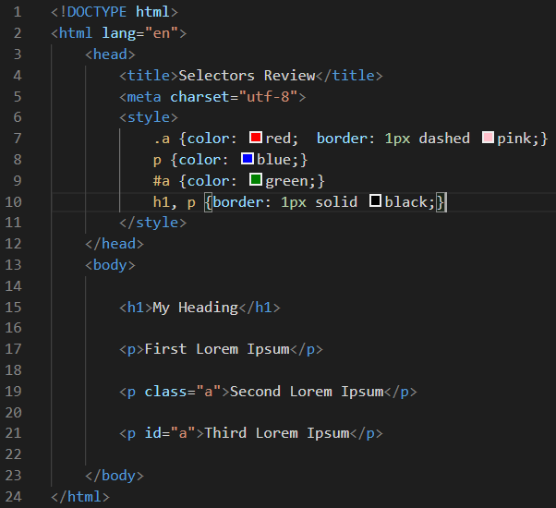

**CSS Review**

1. What kind of stylesheet am I using in the document above?

Embedded style sheet

1. What line has a:
   * Element Selector – line 8, 10
   * ID Selector – line 9 (id selector needs a pound sign before it, #)
   * Class Selector – line 7 (they have a period before it, .)
   * Grouped Selector – line 10
2. There is one line of html code with 2 styles being applied to it.
   * What line of html has more than one style being applied to it? Line 19
   * Which lines in the stylesheet show the two different styles? Line 7 and 10 (pink boarder vs black boarder)
   * Which style will prevail in the inheritance? Why? – in inheritance, the more specific you are the more likely that style will be to prevail.
   * What color will the styled line be? Pink